AudioTester User Guide

Version: 1.0.7
DocCode: SW-ALL-DS-0009
Date: May 23, 2011


www.spreadtrum.com
Important Notice
Copyright Notice
Copyright © 2007, Spreadtrum Communications, Inc. All rights reserved.
Trademarks
Spreadtrum Communications, Inc. and Spreadtrum Communications, Inc.'s products are exclusively owned by Spreadtrum Communications, Inc. References to other companies and their products use trademarks owned by the respective companies and are for reference purpose only.
Warranty Disclaimer
Spreadtrum Communications, Inc. makes no representations or warranties, either expressed or implied, by or with respect to anything in this document, and shall not be liable for any implied warranties of merchantability or fitness for a particular purpose or for any indirect, special or consequential damages.
Confidentiality
The information contained herein (including any attachments) is confidential. The recipient hereby acknowledges the confidentiality of this document, and except for specific purposes, this document shall not be disclosed to any third party.
About This Document

Purpose
The AudioTester User Guide describes the functions and how to use AudioTester.

Intended Audience
This document is intended for:
- Production test engineer

Organization
This document consists of two chapters and is organized as follows.
Chapter | Describes
1 Basic Operations | The functions, running requirements, and how to use AudioTester.
2 Parameter Debugging | The parameter debugging interface and procedure.

Contents
1 Basic Operations 1-1
1.1 Functions 1-1
1.2 Running Requirements 1-1
1.3 Main Interface 1-1
1.4 Connecting with ChannelServer 1-2
1.5 Connecting with phone directly 1-3
1.6 Loading Parameters from Mobile 1-3
1.7 Saving Parameters 1-6
1.8 Loading Parameters from File 1-6
1.9 Exporting Parameters 1-7
1.10 Importing Parameters 1-8
1.11 Making a Call and Hanging Up 1-9
1.12 Enter Test Mode 1-9
2 Audio Parameter Debugging 2-11
2.1 Main Interface 2-11
2.2 Sound effects 2-11
2.3 Product Info 2-13
2.3.1 DA Device 2-13
2.3.2 AD Device 2-14
2.3.3 dl PGA gain 2-14
2.3.4 ul PGA gain 2-15
2.3.5 Volume 2-15
2.3.6 AEC 2-16
2.3.7 Sample Rate 2-16
2.3.8 Sidetone 2-16
2.4 Gain 2-16
2.4.1 AGC Switch/ALC Switch 2-16
2.4.2 DL_Digital_gain 2-17
2.4.3 UL_Digital_gain 2-17
2.4.4 Loopback_gain 2-18
2.5 EQ 2-18
2.5.1 Downlink EQ 2-18
2.5.2 Uplink EQ 2-19
2.5.3 FIR 2-19
2.6 NG 2-22
2.7 DePop 2-22
2.8 AEC 2-22
2.9 XAGC 2-24
2.10 DL Clarity 2-25
2.11 UL Clarity 2-26
2.12 Volume config 2-27
2.13 Command 2-28
2.13.1 Volume control 2-28
2.13.2 Speaker off 2-29
2.13.3 Mute 2-29
2.13.4 Default fir 2-29
2.14 Writing/Loading the Parameters in Mobile 2-29
2.14.1 Writing the Paramters in RAM 2-29
2.14.2 Writing the Parameters in Flash 2-29
2.14.3 Loading the parameters from RAM 2-29
2.14.4 Loading the parameters from Flash 2-29
2.15 NXP 2-29
2.15.1 TX Parameters 2-29
2.15.2 RX Parameters 2-30
2.15.3 NXP_VOICE Boost_CTL 2-30
2.16 Version Description 2-31
3 Music Parameter Debugging 3-32
3.1 Main Interface 3-32
3.2 Device 3-33
3.3 Sound effect 3-33
3.3.1 Lcf set 3-33
3.3.2 Eq set 3-34
3.3.3 Alc set 3-36
3.4 App gain 3-37
3.4.1 App type 3-37
3.4.2 Eq Sel 3-37
3.4.3 File 3-37
3.4.4 Volume 3-37

Figures
Figure 1-1 Main interface 1-2
Figure 1-2 Successfully loading parameters 1-3
Figure 1-3 Confirming loading 1-4
Figure 1-4 Saving audio parameters 1-4
Figure 1-5 Opening a file 1-5
Figure 1-6 Saving the parameters in NVEditor 1-6
Figure 1-7 Importing parameters from file 1-6
Figure 2-1 Parameter debugging 2-10
Figure 2-2 Eq parameters 2-11
Figure 2-3 DA Device dialog box 2-12
Figure 2-4 AD Device dialog box 2-13
Figure 2-5 DL PGA Gain dialog box 2-13
Figure 2-6 UL PGA Gain dialog box 2-14
Figure 2-7 DL_Digital_gain dialog box 2-15
Figure 2-8 UL_Digital_gain dialog box 2-15
Figure 2-9 Sidetone_gain dialog box 2-15
Figure 2-10 DL_EQ dialog box 2-16
Figure 2-11 Refer to the previous section. The only difference is that the Middle area is invalid. 2-16
Figure 2-12 DL_FIR dialog box 2-17
Figure 2-13 FIR auto interface 2-18
Figure 2-14 NG settings dialog box 2-19
Figure 2-15 Popn dialog box 2-19
Figure 2-16 Aec dialog box 2-19
Figure 2-17 XAGC dialog box 2-20
Figure 2-18 DL Clarity dialog box 2-20
Figure 2-19 UL Clarity dialog box 2-22
Figure 2-20 Volume config dialog box 2-23
Figure 2-21 Volume control dialog box 2-23

Tables
Table 1-1 AT+CMEE=<value> 1-6

Basic Operations

Functions
Spreadtrum AudioTester is used to debug the audio parameters in order to achieve the best audio effect.

Running Requirements
AudioTester runs on Windows2000. It must be used together with Spreadtrum ChannelServer.

Main Interface
-3 shows the main interface of AudioTester.

Main interface
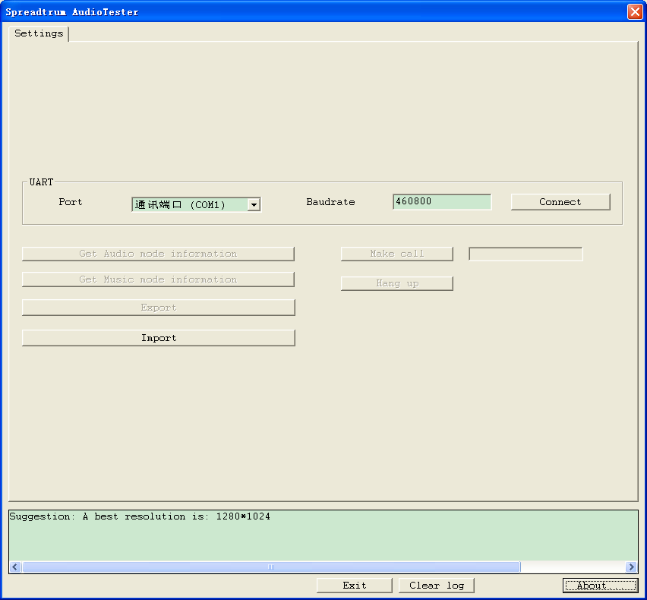

Connecting with ChannelServer
          - Run ChannelServer and set the parameters. For details, refer to the ChannelServer User Guide.
          - Connect AudioTester to ChannelServer through Socket.
          - On the main interface shown in 1.3.1 -3, fill in the IP Address and Port text boxes and then click Connect.
- If connection is successful, Connect will change to Disconnect.
- If connection fails, the Log area will display the error message. Check whether the parameters are correctly set.
If Audiotester version is above 1.2.3002 and Channelserver version is above 1.9.0, Audiotester will detect endian mode of the phone automatically, the endian parameter in the configure file is ignored. Otherwise, you should modify the endian parameter in the configure file. “endian” is 1 means big-endian, 0 means little-endian.

Connecting with phone directly
You can also connect with phone directly using UART or USB. Choose a port and fill the baudrate, click Connect button, you can connect with the phone.
- If connection is successful, Connect will change to Disconnect.
- If connection fails, the Log area will display the error message. Check whether the parameters are correctly set.
In this mode, Audiotester will detect endian mode of the phone automatically. The endian parameter in the configure file is ignored.

Loading Parameters from Mobile
Get Audio Parameters:
After successfully connecting AudioTester to ChannelServer, you can load the mobile audio parameters by clicking Get Audio Information on the main interface.
The loading progress is displayed in the Log area.
If loading is successful, the Headset, Handset, and Handsfree tabs are displayed, as shown in -3.

Successfully loading parameters
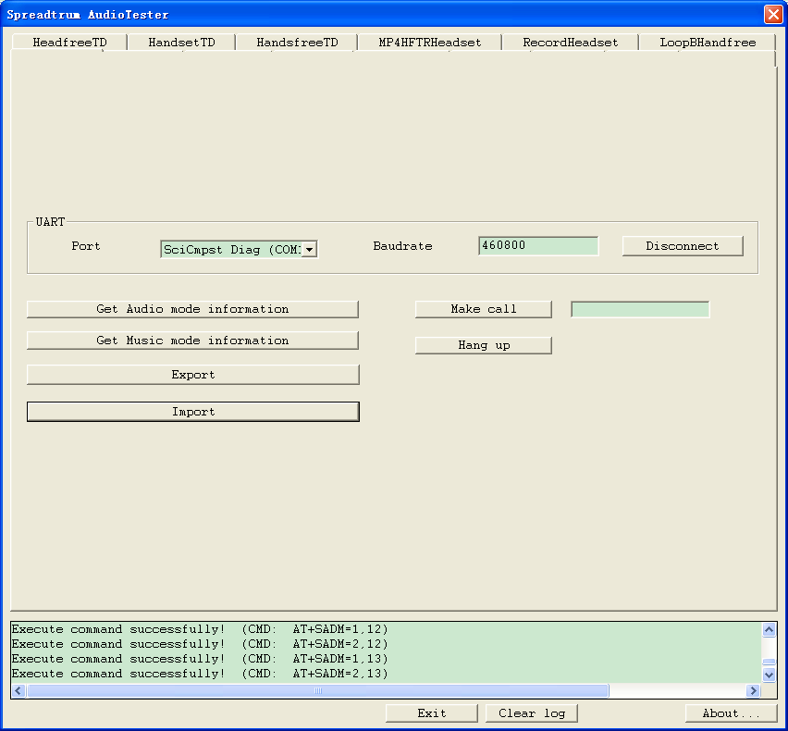

If you already load the audio parameters and click Get Audio mode information again, a dialog box shown in -3 is displayed.

Confirming loading
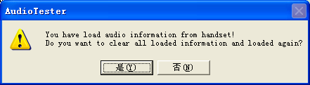

Click Yes. AudioTester clears the existing audio information and loads the parameters again. Click No to cancel the operation.
Get Music Parameters:
This mode is used on 8800G only.
After successfully connecting AudioTester to ChannelServer, you can load the mobile audio parameters by clicking Get Music Information on the main interface.
The loading progress is displayed in the Log area.
If loading is successful, the some tabs are displayed, as shown in -3.

Confirming loading Music Parameters
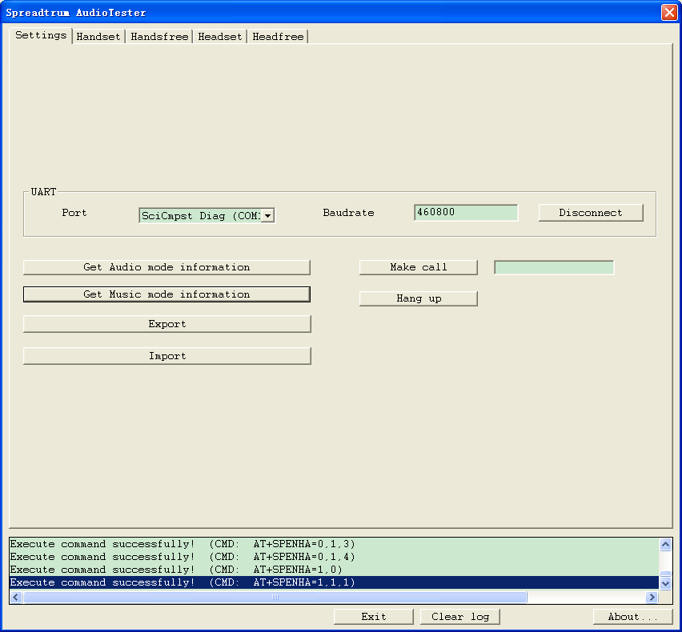
If you already load the audio parameters and click Get Music mode information again, a dialog box will be displayed.

Saving Parameters
Click Save on the main interface. The Save as dialog box is displayed, as shown in -3. Select the saving directory. The default file name is *.aud.

Saving audio parameters
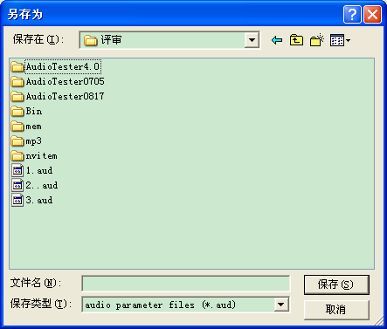

Loading Parameters from File
Note:
This function can be used when AudioTester and ChannelServer are not connected.
Click Load on the main interface. The Open File dialog box is displayed, as shown in -3. The file version, created time, pc name, and data size is displayed in the dialog box.

Opening a file
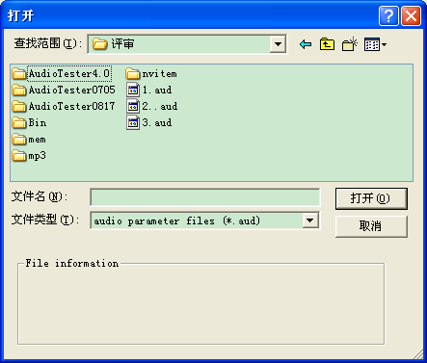

If you already load the audio parameters and click Get Audio mode information again, a dialog box shown in 1.6.1 -3 is displayed.
Click Yes. AudioTester clears the existing audio information and loads the parameters again. Click No to cancel the operation.

Exporting Parameters
Spreadtrum NVEditor is used to export and save the debugged parameters and to download the parameters to the mobile.
Click Export on the main interface. The dialog box shown in -3 is displayed. Select the saving directory. The default file name is *.nv.

Saving the parameters in NVEditor
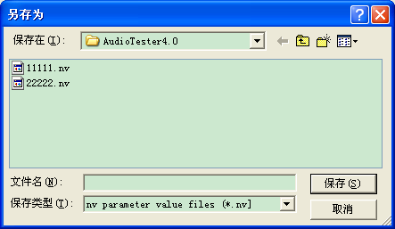

Importing Parameters
AudioTester supports to import parameters from “*.nv” file.
Click Import on the main interface. The dialog box shown in 1.9.1 -3 is displayed. Select the saving directory. The default file name is *.nv.

Importing parameters from file

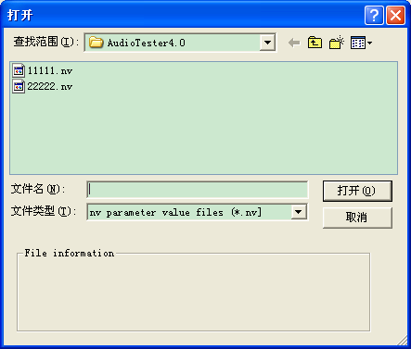

Making a Call and Hanging Up
Some parameters must be debugged during a call.
Type the phone number in the text box and click Make call to make a call. Click Hang up to hang up.
Table 1-1 describes command AT+CMEE.
                - AT+CMEE=<value>
<value> | Description
0 | Cancel +CME ERROR
1 | Activate +CME ERROR and use error numerals.
2 | Activate +CME ERROR and use detailed description.
Note: Please make sure “SIM Card” is plugged in “SIM1” position in the phone. Audiotester made call from SIM1 by default.

Enter Test Mode
“Test Mode” includes three functions: open mix mode, close arm log, and close deep sleep.
[Open mix mode]: AudioTester sends AT+SUPS=1 to MS, if it success returns “OK”, and then returns “+CME ERROR”.
[Close arm log]: AudioTester sends diag command to MS, whose type is 02, and subtype is 05.
[Close deep sleep]: AudioTester sends diag command to MS, whose type is 17, and subtype is 0xC.

Audio Parameter Debugging

Main Interface
After loading the parameters, you can debug them on relevant tab pages.
Pay attention to the following points:
- Some versions do not support DL FIR, UL FIR, ST FIR, or Extend data. These buttons are unavailable in this case.
- Downlink EQ is multiplexed as FIR in some versions.
- AEC is multiplexed as XAGC in some versions.
- The buttons of the parameters that are not used are unavailable.
-3 shows the parameter debugging interface.

Parameter debugging

Sound effects
A sound effect supplies the method of adjusting mp3/midi/mp4/voice parameters.
Agc switch : on-off of agc
Lcf switch: on-off of lcf filter
Agc input gain: agc input gain (range 0-32767)
Vdg position: position of vdg（before or after）
Eq select: selecting eq parameters
Click <eq set> button, the follow dialog is shown which is used to adjusting eq parameters:

Eq parameters
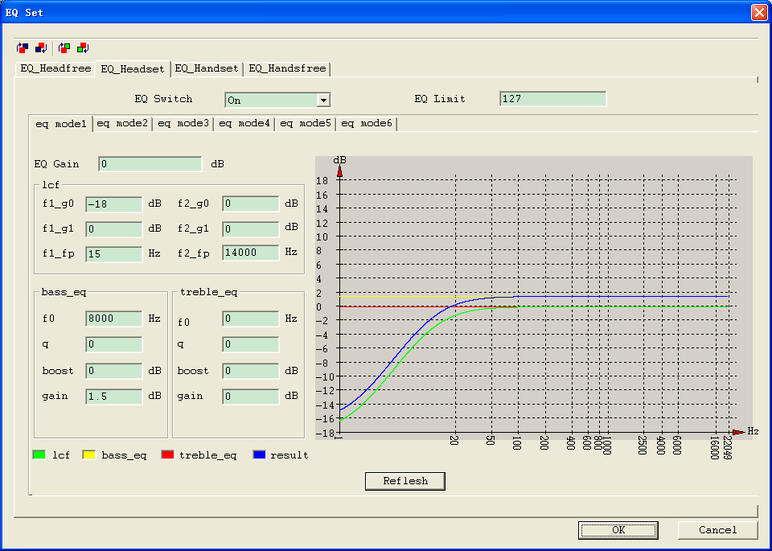
EQ Switch: on-off of eq
EQ Limit : limit setting of eq (range0-127)
EQ Gain : gain of eq (range -12-0)
<lcf>
f1_g0 : gain of filter1 based0 hz (range -72-18)
f1_g1 : gain of filter1 based fs/2 hz(dB) (range -72-18)
f1_fp : ending frequency of filter1（Hz）(range 0-22050)

f2_g0 : gain of filter2 based0 hz (range -72-18)
f2_g1 : gain of filter2 based fs/2 hz(dB) (range -72-18）
f2_fp : ending frequency of filter1（Hz）(range 0-22050)
<bass_eq>
f0: centern frequency（Hz）(range 0-22050)
q: value of Q; df =f0/q
boost: relatively gain of f0（dB）(range 72-18)
gain: gain of filter（dB）(range -72-18)
<treble_eq> （same to bass_eq）
Click <Volume Set> button, the follow dialog is shown which is used to adjusting arm volume parameters:

Arm volume parameters
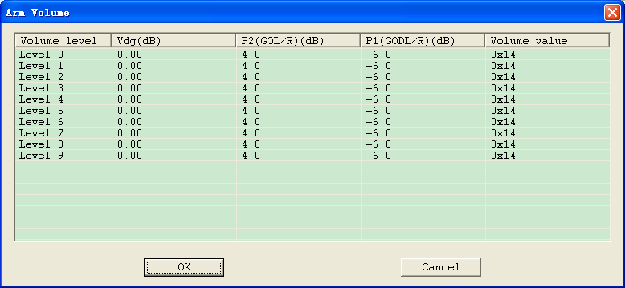
“Vdg”,” P2(GOL/R)” and ” P1(GODL/R)” can be modified by user, but “Volume value” can not be edited.

Product Info

DA Device
Click DA Device. The DA Device dialog box is displayed, as shown in -3.

DA Device dialog box
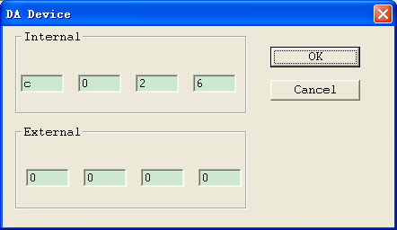

Type a hex number, namely, 0~9 or 0xA~0xF in each text box. Then click OK.

AD Device
Click AD Device. The AD Device dialog box is displayed, as shown in -3.

AD Device dialog box
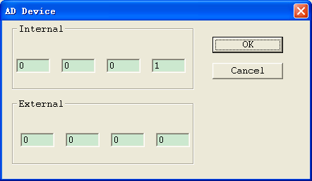

Type a hex number, namely, 0~9 or 0xA~0xF in each text box. Then click OK.

dl PGA gain
Click dl PGA gain. The DL PGA Gain dialog box is displayed, as shown in -3.

DL PGA Gain dialog box
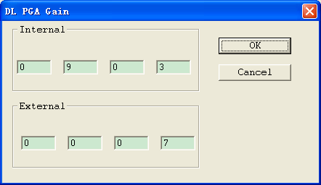

Type a hex number, namely, 0~9 or 0xA~0xF in each text box. Then click OK.

ul PGA gain
Click ul PGA gain. The DL PGA Gain dialog box is displayed, as shown in -3.

UL PGA Gain dialog box

Type a hex number, namely, 0~9 or 0xA~0xF in each text box. Then click OK.

Volume
Volume drop-down list box is used for volume control.

AEC
AEC drop-down list box is used for echo canceling.

Sample Rate
The sample rate can be 8K or 16K.

Sidetone
- Sidetone
- Sidetone EQ
- Sidetone CP

Gain

AGC Switch/ALC Switch
AGC/ALC Switch can be set on or off.
If it is Audio4.1 version, the dialog is displayed as follow:

ALC Switch dialog box
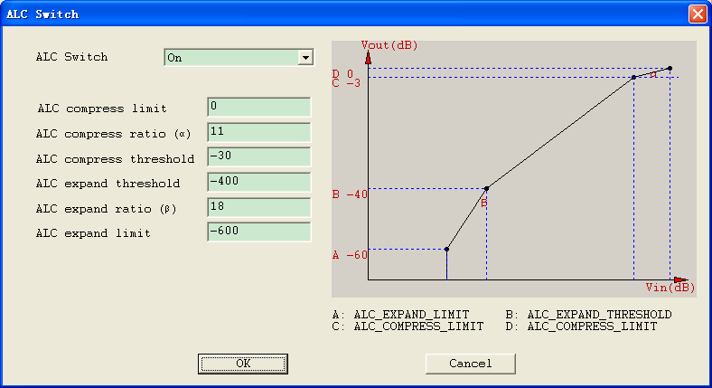
ALC compress ratio and ALC expand ratio only displayed in Samsung version.
If it is Audio4.0 version, the dialog is displayed as follow:

ALC Switch dialog box
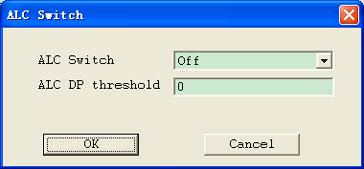
If it is others version, the dialog is displayed as follow:

AGC Switch dialog box
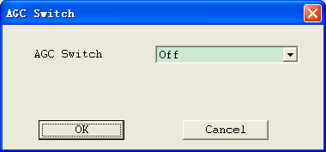

DL_Digital_gain
Click DL_Digital_gain. The DL_Digital_gain dialog box is displayed, as shown in -3.

DL_Digital_gain dialog box
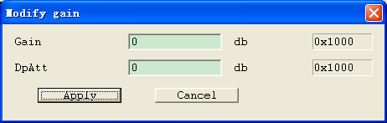

UL_Digital_gain
Click UL_Digital_gain. The UL_Digital_gain dialog box is displayed, as shown in -3.

UL_Digital_gain dialog box
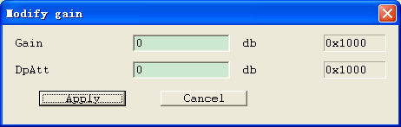

Loopback_gain
Click Sidetone_gain. The Sidetone_gain dialog box is displayed, as shown in -3.

Sidetone_gain dialog box
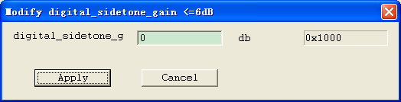

EQ
In the EQ area, you can debug the uplink and downlink equalization parameters.
If the sixth bit of dl_eq_switch is 1, the Downlink EQ button in the EQ area will change to FIR.

Downlink EQ
Click Downlink EQ. The DL_EQ dialog box is displayed, as shown in -3.

DL_EQ dialog box
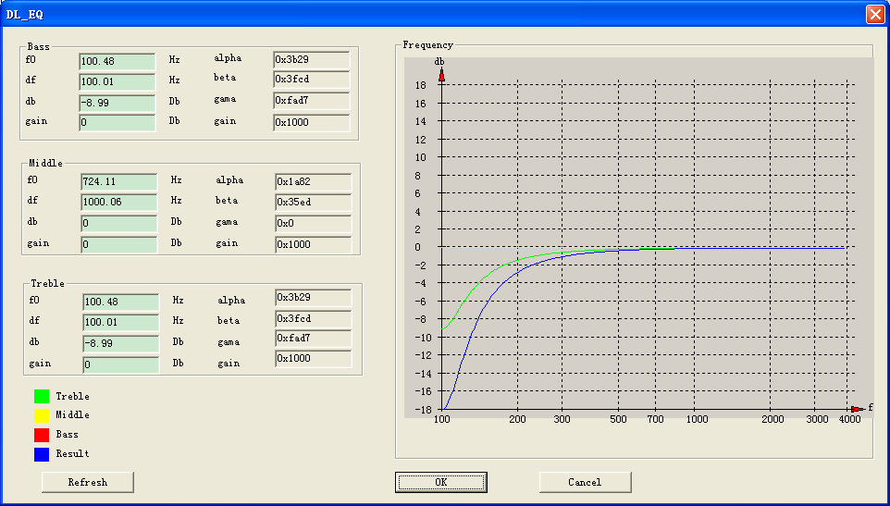

The alpha, beta, gama, and gain boxes show the results calculated from f0, df, db, and gain. The curves in the Frequency area show changes of the parameters.
Click Refresh. You can see the calculated results and the updated curves.

Uplink EQ

Refer to the previous section. The only difference is that the Middle area is invalid.

FIR
Click FIR. The DL_FIR dialog box is displayed, as shown in -3.

DL_FIR dialog box
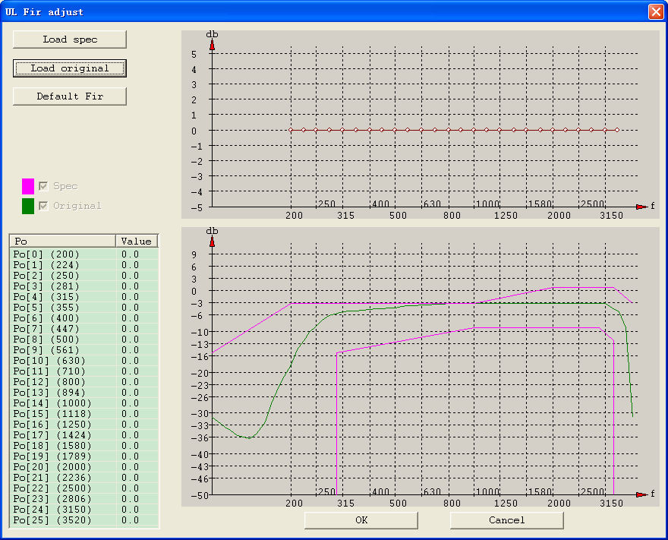

Click Load original to import a original curve as the green curve. By dragging the FIR parameters in the top image to change the shape of the green curve, when it is satisfied, click OK to save it. When open the dialog next time, the green curve will show as last time.
In the Power Value area, you can adjust the power. The adjustment step length is 1.5. The curve in the Frequency area changes accordingly during the adjustment.
In the Coefficient area, the calculated mobile parameters are displayed. The parameters can be loaded to the mobile afterwards.
Fill in the eq_fir_gain text box.
[FIR Auto Adjust]:
Click “Auto” button to open the auto-adjust dialog box. Loading EQ spec, original and target files, and then click “Adjust” button, AudioTetser will adjust FIR parameters automatically. Input value in “FIR offset”, and click “Apply” button to adjust the FIR value based on automatically adjusted. If clicking “OK”, it will return to the DL_FIR interface, the adjusted value also displayed in this dialog, if clicking “Cancel”, the result that adjusted automatically will be thrown away.
The dialog box is shown as follow:

FIR auto interface
2-1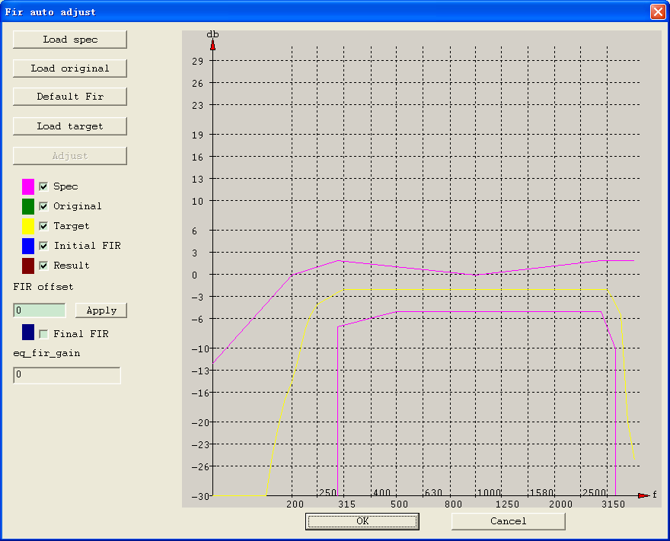
The colorful item which is in the left-middle window corresponds to the colorful curves in the right window, and controls to display the curves or not.
- Spec：GSM spec curve.
- Original：FIR Original curve.
- Target：FIR target curve.
- Initial FIR: FIR result curve.
- Result：Generated by FIR Original curve add to FIR result curve..
- Final FIR：Initial FIR adds to “FIR offset” value. It is the finally result.
Notes:
- Original and Target files are generated by audio apparatus, may be .trc or .xls file.
- The eq number and frequency value in the original and target files must be equal. If not, AudioTester will advance the user to select using the old data or the new data.

NG
Click NG. The NG settings dialog box is displayed, as shown in -3.

NG settings dialog box
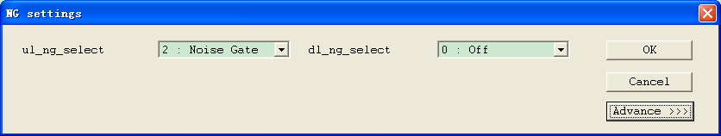

Click Advance. The advanced NG parameters are displayed. However, this function is not supported currently.

DePop
Click DePop. The Pop dialog box is displayed, as shown in -3.

Popn dialog box
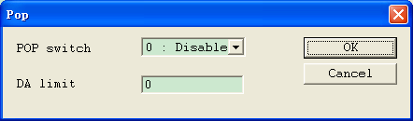

AEC
Click AEC. The Aec dialog box is displayed, as shown in -3.

Aec dialog box
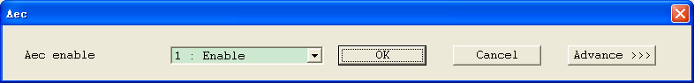

Click Advance. The advanced AEC parameters are displayed. However, this function is not supported currently.
If it is Audio4.0 version, the dialog is displayed as follow:

Aec dialog box

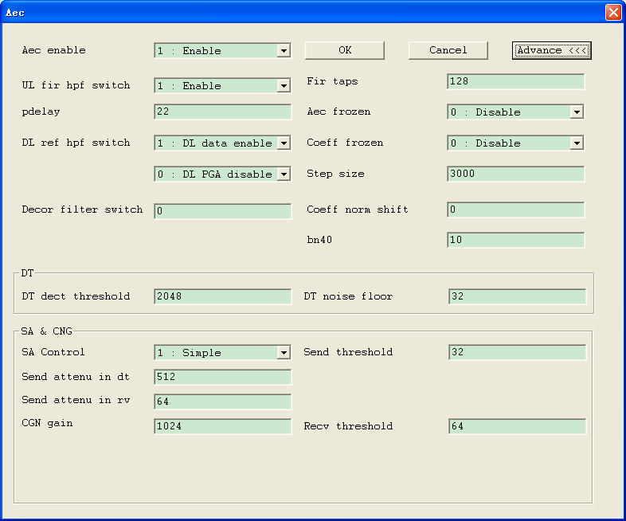
If it is others version, the dialog is displayed as follow:

Aec dialog box

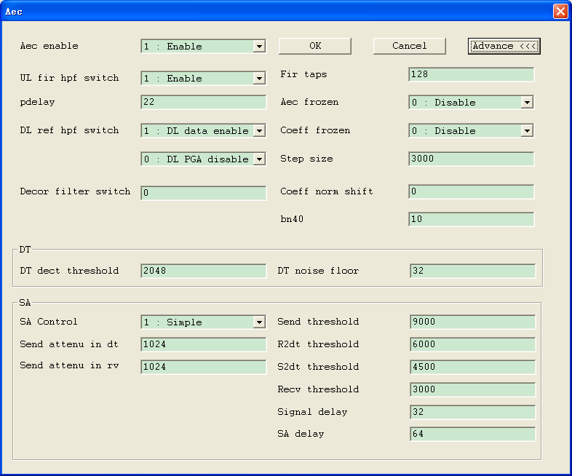

XAGC
When the parameter mode is MP4HFTR and the lowest bit of coeff_norm_shift is 1, AEC is multiplexed as XAGC and the AEC button changes to XAGC.
Click XAGC. The XAGC dialog box is displayed, as shown in -3.

XAGC dialog box
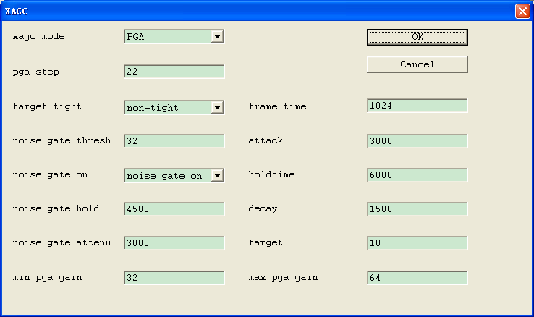

DL Clarity
Click <DL Clarity> button to open DL Clarity dialog box, which shown as follow:

DL Clarity dialog box

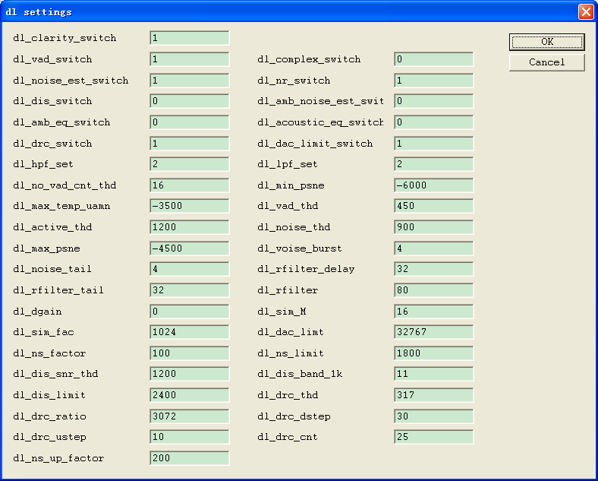

UL Clarity
Click <UL Clarity> button to open UL Clarity dialog box, which shown as follow:

UL Clarity dialog box
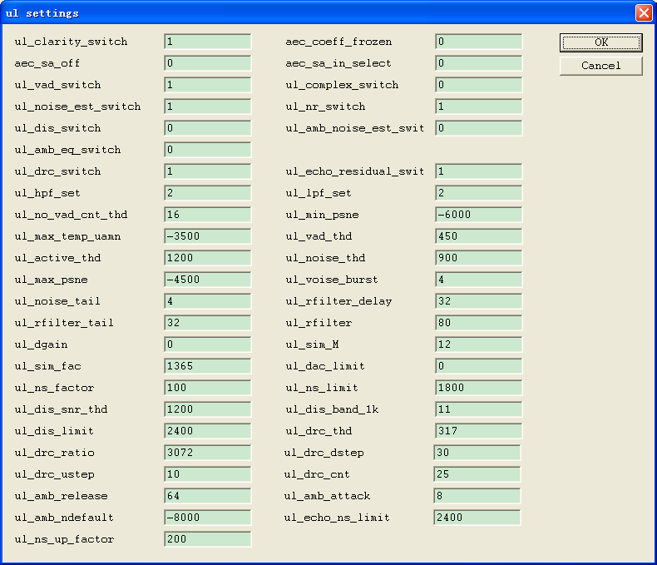

Volume config
“Volume config” adjust parameters of volume. Click <Volume config> button to open the dialog box, which shown as follow:

Volume config dialog box
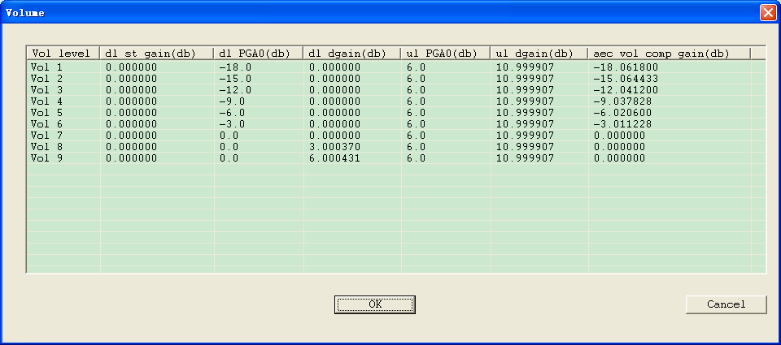
There are 9 levels that in the first column need to be adjusted. Double click the grid under the dl_st_gain, dl_dgain and aec_vol_comp_gam, and then you can edit the value in it, the unit of the value is db, the range is -100 to 18. Double click the grid under dl_PGA0 and ul_PGA0, and then you can select the value that displayed in the combo box.

Command

Volume control
Click Volume control. The Volume control dialog box is displayed, as shown in -3.

Volume control dialog box
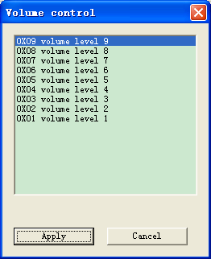

Select the volume and click Apply.

Speaker off
The speaker can be set on or off.

Mute
This command is valid only during a call.

Default fir
“Default FIR” button will load original dl, ul and st fir parameters to phone.

Writing/Loading the Parameters in Mobile

Writing the Paramters in RAM
Click to write the parameters in RAM.
The debugged parameters are lost after the mobile is restarted.

Writing the Parameters in Flash
Click to write the parameters in mobile NV.
The debugged parameters are still valid after the mobile is restarted. Perform this operation after writing the parameters in RAM.
The debugged parameters are lost after the mobile software is upgraded.

Loading the parameters from RAM
Click to load the parameters from the RAM.

Loading the parameters from Flash
Click to load the parameters from Flash

NXP
This function is only displayed in “Headset”,”Headfree”,”Handset”,”Handsfree” mode.

TX Parameters
TX Parameters is shown as bellow:

TX Parameters
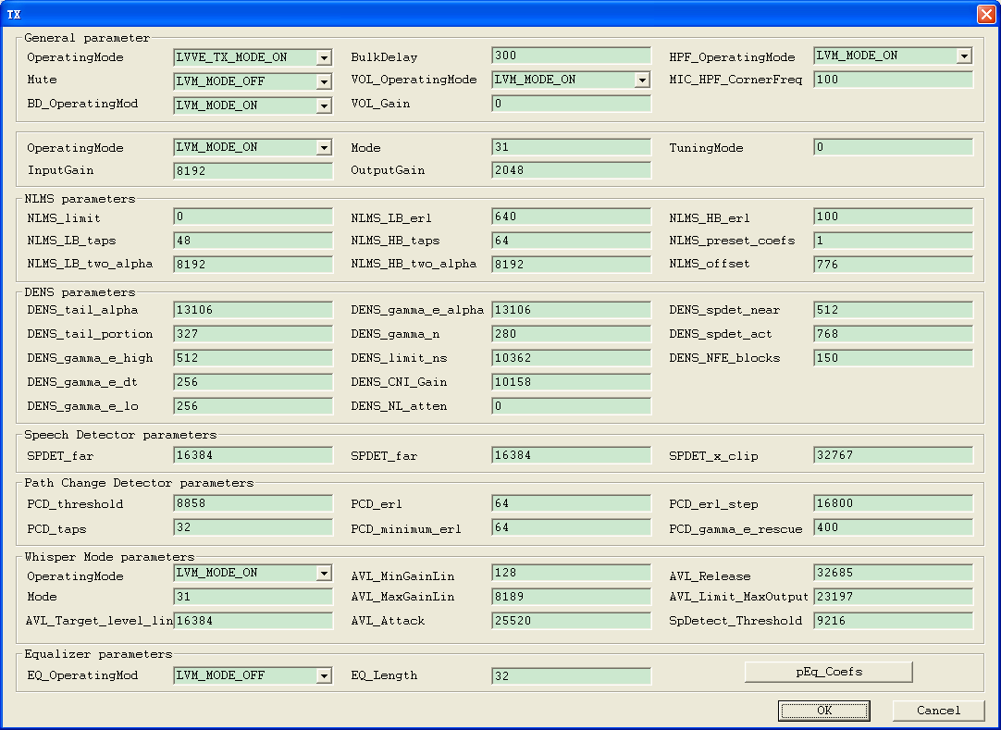

RX Parameters
RX Parameters is shown as bellow:

RX Parameters
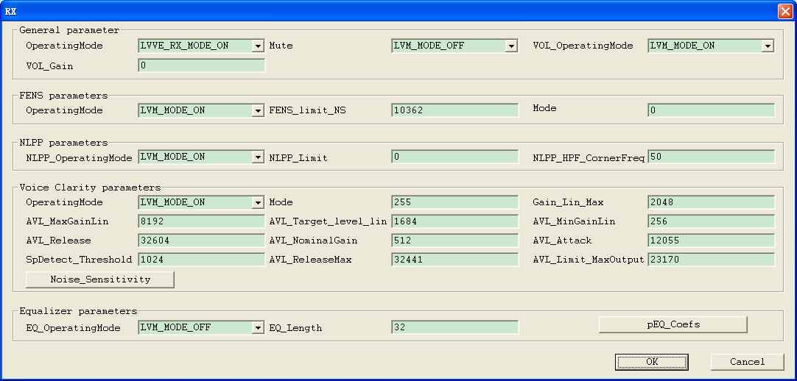

NXP_VOICE Boost_CTL
NXP_VOICE Boost_CTL is shown as bellow:

NXP_VOICE Boost_CTL
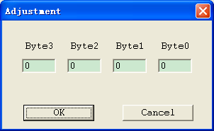
NXP_VOICE Boost_CTL is displayed in “Headset”,”Headfree”,”Handset”,”Handsfree” mode and “HeadsetTD”,”HeadfreeTD”,”HandsetTD”,”HandsfreeTD” mode.

NXP_Dump_PCM_CTL
NXP_Dump_PCM_CTL is shown as bellow, only displayed in “Handsfree” mode:

NXP_Dump_PCM_CTL

Version Description
The audio file format changes with the upgrade of AudioTester. Currently, the official versions are 2.0 , 3.0 and 4.0.
- Version 2.0 consists of two versions, the difference between which lies in the structure size.
- The structure size of the earlier version is 88 words. The earlier version can only be opened by version 1.0.1 or earlier.
- The structure size of the later version is 230 words. The later version can be opened by version 1.0.2 or later.
- Version 3.0 has the structure size, namely, 88 words, 230 words, and 250 words added in its header. It can only be opened by version 1.0.4 or later.
- Version 1.0.4 or later can also be used to open version 2.0 (structure size: 230 words).
- Version 4.0 has the eq parameters adding the end of the aud file.
- Music参数调试

Music Parameter Debugging

Main Interface
After loading the parameters, you can debug them on relevant tab pages.
2.1.1 -3 shows the parameter debugging interface.
Note：This mode is only used on 8800G now.
Figure 3-2 Setting interface
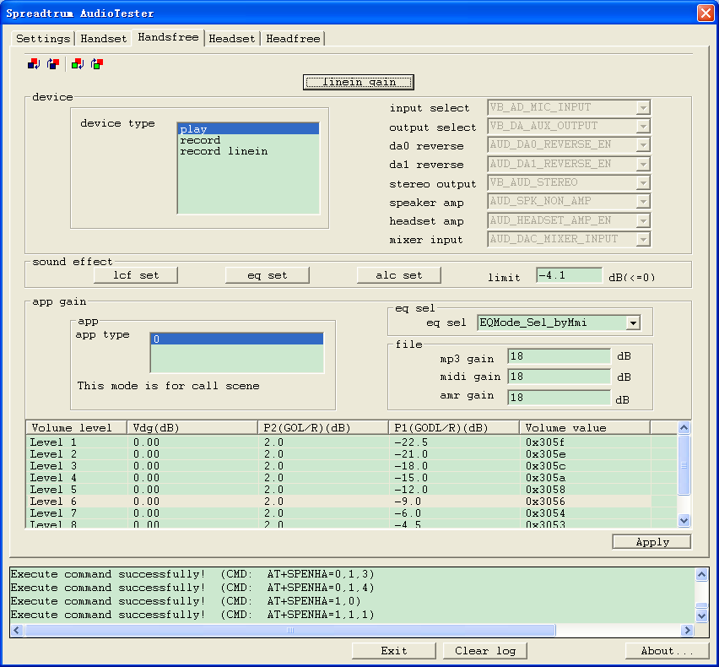

Linein gain
This button only displayed in “Headset” and “Handsfree”.
Click linein gain, the dialog will be shown as bellow:
Figure 3-3 Setting interface
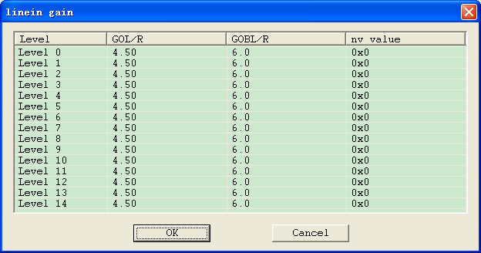

Device
The parameters in Device are loaded from the phone.
When user select different item in device type, the parameters in the right will be changed, but can not be edit.

Sound effect

Lcf set
The interface of lcf set is shown as 2.1.1 -3:
Figure 3-4 Lcf set
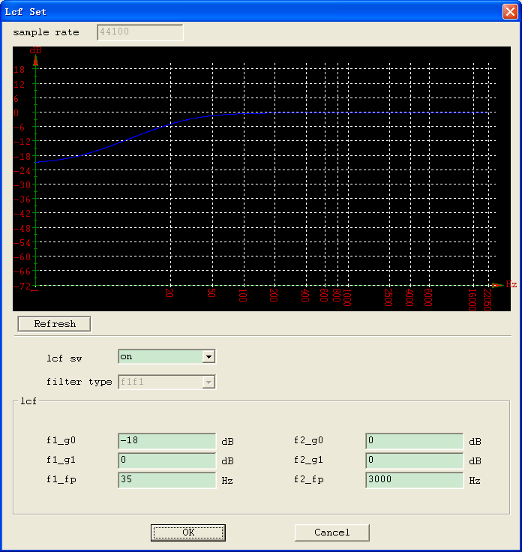
Lcf sw: On or Off. When it is on, the parameters in lcf can be edit; when it is off, the parameters in lcf can not be edit.
Filter type: 0: f1f1
1: butterworth
2: chebyshev
3: bessel
4: ellipitical
Lcf: this parameters is loaded from phone.

Eq set
The interface of lcf set is shown as 2.1.1 -3:
Figure 3-5 eq set
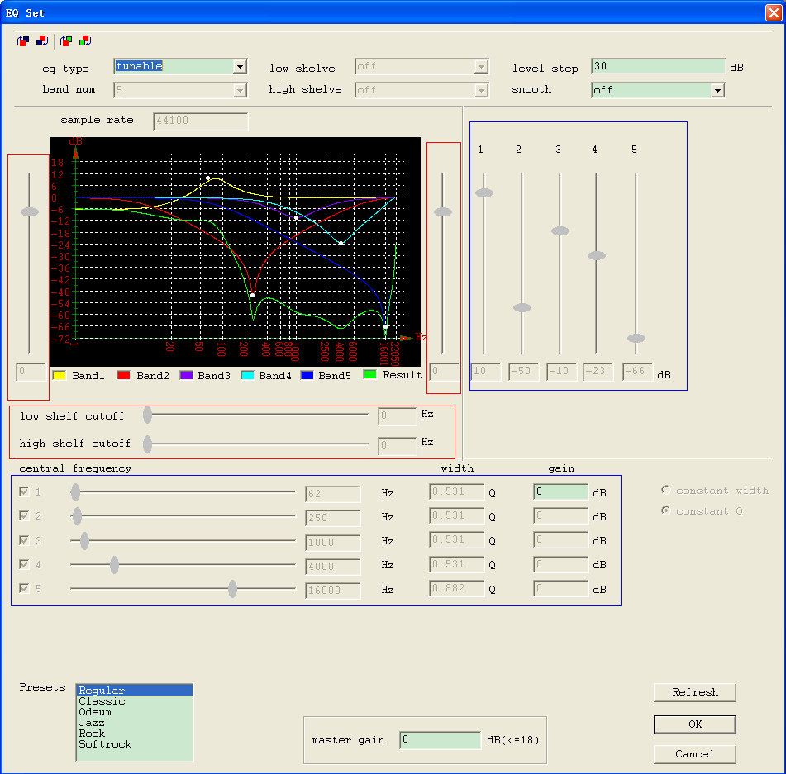
Eq type: untunable or tunable
Band num: 5 or 8
Low shelve: on or off
High shelve: on or off
Level step: when eq type is untunable, this item can not be edit
Smooth: when eq type is untunable, this item can not be edit
0 --- off
1 --- leak compensation
2 — averge gain
3 --- AvergeAndLeakCompensation
Sample rate: 44100, can not be edit
Graph: the graph of band.
Presets: includes value as bellow, when select different value, the item in the blue rect will be changed.
Regular
Classic
Odeum
Jazz
Rock
Softrock
Master gain: different with the value of presets.
Refresh: refresh the graph
Note: the red rect in the dialog is reversed.

Alc set
The interface of lcf set is shown as 2.1.1 -3:

Alc set
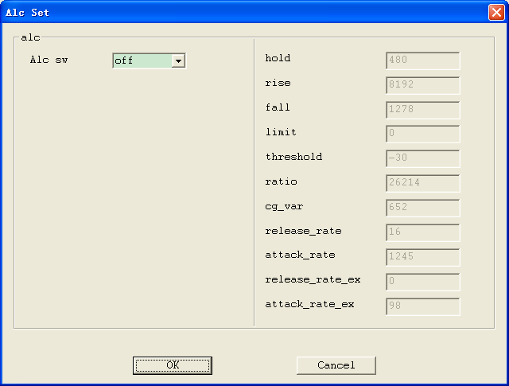
Alc sw: on or off. When it is on, the parameters in the right can be edit. When it is off, the parameters in the right can not ba edit.
Right parameters: Load from the phone, can be edit when alc sw is on.

App gain

App type
App type includes value as bellow:
app type == 0
app type == 1
app type == 2
app type == 3
app type == 4
When user selected different value in app type, eq sel, file and volume will be changed.

Eq Sel
Eq sel includes value as bellow:
0 – EQMode_Sel_Off
1 - EQMode_Sel_Regular
2 - EQMode_Sel_Classic
3 - EQMode_Sel_Odeum
4 - EQMode_Sel_Jazz
5 - EQMode_Sel_Rock
6 - EQMode_Sel_Softrock
15- EQMode_Sel_byMmi
Other value - EQMode_Sel_Error

File
Load from phone, can be edit.

Volume
Load from phone, can be edit. Click Apply can write the current high light item to the phone.

